[Title in Times New Roman and Bold No.14]

Last name -First name, (in uppercase) -1st † Last name -First name (in uppercase) -2nd Author's name
Institutional mail No.10 Times New Roman and Italic

(Report Submission Date: Month, Day, and Year); Accepted (Insert date of Acceptance: Use Only ECORFAN)
___________________________________________________________________________________________________

Abstract

Title

Objectives, methodology

Contribution

(150-200 words)

Keywords

Indicate (3-5) keywords in Times New Roman and Bold No.11

___________________________________________________________________________________________________

Citation: Last name -First name (in uppercase) -1st † Last name -First name (in uppercase) -2nd Author's name. Paper Title. Title of the Journal. 2015 1-1: 1-11 - [All in Times New Roman No.10]
___________________________________________________________________________________________________

___________________________________________________________________________________________________
† Researcher contributing as first author.
© ECORFAN-( Indicate the country of publication) www.ecorfan.org/ Indicate the country of publication

Introduction

Text in Times New Roman No.12, single space.

General explanation of the subject and explain why it is important.

What is your added value with respect to other techniques?

Clearly focus each of its features

Clearly explain the problem to be solved and the central hypothesis.

Explanation of sections Article.

Development of headings and subheadings of the article with subsequent numbers

[Title No.12 in Times New Roman, single spaced and Bold]

Products in development No.12 Times New Roman, single spaced.

Including graphs, figures and tables-Editable

In the article content any graphic, table and figure should be editable formats that can change size, type and number of letter, for the purposes of edition, these must be high quality, not pixelated and should be noticeable even reducing image scale.

[Indicating the title at the bottom with No.10 and Times New Roman Bold]
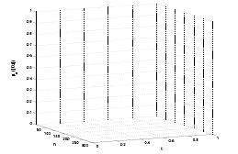

Graphic 1 Title and Source (in italics).

Should not be images-everything must be editable.

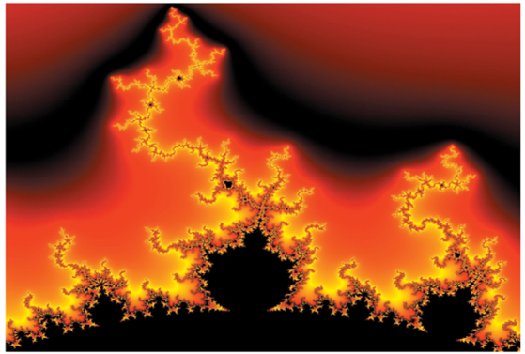

Figure 1 Title and Source (in italics).

Should not be images-everything must be editable.

Table 1 Title and Source (in italics).

Should not be images-everything must be editable.

Each article shall present separately in 3 folders: a) Figures, b) Charts and c) Tables in .JPG format, indicating the number and sequential Bold Title.

For the use of equations, noted as follows:

$Y_{ij}=α+ \sum_{h=1}^{r}{β_{h}X_{hij}}+u_{j}+e_{ij}$ (1)

They must be editable and number aligned on the right side.

Methodology

Develop give the meaning of the variables in linear writing and important is the comparison of the used criteria.

Results

The results shall be by section of the article.

Annexes

Tables and adequate sources thanks to indicate if they were funded by any institution, University or company.

Conclusions

Explain clearly the results and possibilities of improvement.

References

Using APA system, should Not be numbered, either bulleted, however, if necessary, will be because reference number or referred to in any of the article.

Data Sheet

Each article must submit your dates into a Word document (.docx):

Journal Name
Article title
Abstract
Keywords
Article sections, for example:

1. Introduction
2. Description of the method
3. Analysis from the regression demand curve
4. Results
5. Thanks
6. Conclusions
7. References

Author Name (s)
Email Correspondence to Author
References

